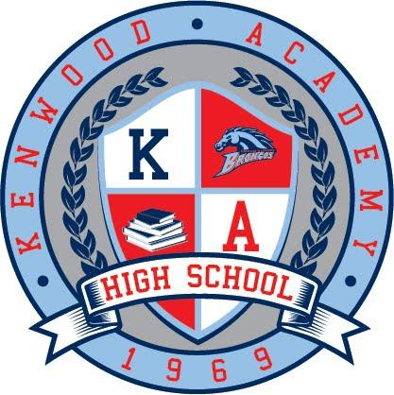

Gregory L. Jones, Ed.D.
Principal

Karen Calloway
Assistant Principal

Thomas Frayne
Assistant Principal

Corrine O'Connell
Assistant Principal

Music Department:

Gerald D. Powell
Director of Bands
Music Department Chair

Ernestine Fleming-Jones
Orchestra Director

Richard Nunley, Jr.
Choral Director

Bethany Pickens
Piano Instructor

Kenwood Bands’ Most Recent Accomplishments:

- In keeping with the Kenwood tradition of excellence, the Concert Band, Jazz Band and Jazz Combo earned Superior ratings in the Spring 2016 IHSA and CPS competitions.
- The Marching Band participates annually in the Bud Billiken Parade and the Hyde Park 4th of July Parade.
- The Drumline participates annually the Hyde Park Children’s Book Fair.
- The Marching Band performed at Ikram Goldman’s 15th Anniversary Bash and was featured in Vogue Magazine’s online edition in May 2016.
- The Marching Band performed for the August 2016 National Conference of State Legislatures at McCormick Place.
- Because of strong commitment to higher education for our students, graduating seniors receive college music scholarships each year.

“Jazz at the Wood”: Kenwood Jazz Band’s Most Recent Honors:

- The Jazz Band performed in the Hyde Park Jazz Festival in 2009 and hosted and performed in the Hyde Park Jazz Festival in 2014-2015.
- For nine consecutive years (2007-2016), the Jazz Band has been invited to perform at the renowned Chicago Jazz Festival in Millennium Park.
- The Wall Street Journal heralded the Kenwood Jazz Band as “one of Sunday afternoon’s best performances” at the 2015 Chicago Jazz Festival. (Sept. 8, 2015, Article by Martin Johnson)
- The Jazz Band performed at the Symphony Center (May 2014) with famed pianist Jason Moran and Chicago-based visual artist, Theaster Gates. The band was featured in the Arts & Entertainment Section of the Chicago Tribune and in Kenwood’s Journey, an Emmy Award winning documentary which chronicled the Jazz Band’s performance “journey” with Jason Moran at Symphony Center. The Tribune articles and documentary range from first rehearsals to the Symphony Center performance’s final ovations.
- Five of our students participated in the Ravinia Jazz Program (2014-2016).
- The Jazz Band performed and participated in a panel discussion on the history of jazz at the Pritzker Pavilion, which was sponsored by Illinois Humanities (June 2016). This panel included Dr. Walter Massey, Victor Goines, and Howard Reich and was facilitated by Kate Dumbleton.

Upcoming Opportunity: The Kennedy Center, Washington, D.C.:

- The Jazz Band will again join Jason Moran with Chicago-based visual artist, Theaster Gates, to perform at The John F. Kennedy Center for the Performing Arts in Washington, DC. On February 24, 2017. This will be a proud and excellent representation of our school, the Hyde Park community, and the city of Chicago.
- Through strong parental support, our band program used the Snap Raise fundraising and donor site to raise $7,203. This amount was used to purchase uniforms for the 30 students who make up the Jazz Band and the Marching Band drumline.
- The Kennedy Center has purchased airline tickets for the 32 students and 6 chaperones and will also pay for hotel accommodations.
- Funding to transport instruments is still needed. The estimated cost is $5,000.

Kenwood Instrumental Music Association ♦ 5015 S. Blackstone ♦ Chicago, IL 60615 ♦ 773-535-1035
Emails: gdpowell@cps.edu, kenwoodbands@gmail.com

